Latter-day Saint women who recognize that their strength comes from the Lord’s Atonement do not give up during difficult and discouraging times. As covenant keepers, we excel at upholding, nurturing, and protecting children and youth so that one day we might say of this rising generation, “Never had I seen so great courage, nay, not amongst all” (Alma 56:45).

Latter-day Saint women who recognize that their strength comes from the Lord’s Atonement do not give up during difficult and discouraging times. As covenant keepers, we excel at upholding, nurturing, and protecting children and youth so that one day we might say of this rising generation, “Never had I seen so great courage, nay, not amongst all” (Alma 56:45).

If We Do Not Doubt
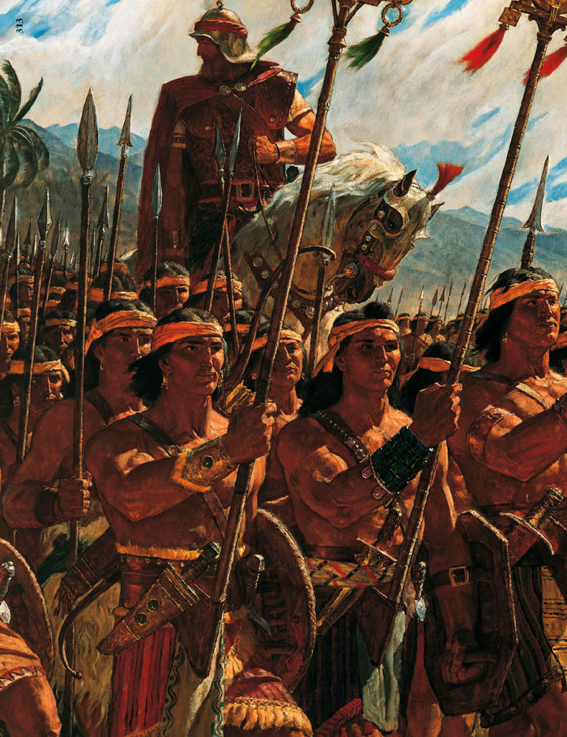

Visiting Teaching Message
October 2011

If We Do Not Doubt

Visiting Teaching Message
October 2011

If We Do Not Doubt
Julie B. Beck, Relief Society general president
In the Book of Mormon we read about exemplary young men who were exceedingly valiant, courageous, and strong. “Yea, they were men of truth and soberness, for they had been taught to keep the commandments of God and to walk uprightly before him” (Alma 53:21). These faithful young men paid tribute to their mothers—their examples and teachers.
The mothers of Helaman’s warriors lived in times not unlike our own... Challenging times cry out for strong parents and examples who teach the truth that Helaman’s warriors knew: “If they did not doubt, God would deliver them” (Alma 56:47). Teaching and exemplifying this truth today requires vigilance. However, we need not fear. When we know who we are and who God is and we have made covenants with Him, we—like these mothers of warriors—will have great influence for good.
Most likely, each of Helaman’s 2,060 warriors was

If We Do Not Doubt
Julie B. Beck, Relief Society general president
In the Book of Mormon we read about exemplary young men who were exceedingly valiant, courageous, and strong. “Yea, they were men of truth and soberness, for they had been taught to keep the commandments of God and to walk uprightly before him” (Alma 53:21). These faithful young men paid tribute to their mothers—their examples and teachers.
The mothers of Helaman’s warriors lived in times not unlike our own... Challenging times cry out for strong parents and examples who teach the truth that Helaman’s warriors knew: “If they did not doubt, God would deliver them” (Alma 56:47). Teaching and exemplifying this truth today requires vigilance. However, we need not fear. When we know who we are and who God is and we have made covenants with Him, we—like these mothers of warriors—will have great influence for good.
Most likely, each of Helaman’s 2,060 warriors was
influenced by a mother. But these mothers did not act alone. Together with other righteous men and women, these mothers must have united their faith and example to teach the power of covenants. The young people of the day understood the covenant their parents had made not to engage in warfare. And even when it seemed impossible, a loving Heavenly Father opened a way for these parents to keep their covenant—and to preserve their liberty (see Alma 56:5–9). We likewise must honor our covenants so that children and youth—our own children and those in our wards, branches, neighborhoods, and communities—will understand and support covenant keeping.
When we honor our covenants, Heavenly Father can prepare the way for us. We are to live our covenants with precision. We can, for example, be precise in praying, in studying the scriptures, in holding a current temple recommend, in dressing modestly, in honoring the Sabbath. As we do so, our children will know and be able to say, “We do not doubt our mothers knew it” (Alma 56:48).

influenced by a mother. But these mothers did not act alone. Together with other righteous men and women, these mothers must have united their faith and example to teach the power of covenants. The young people of the day understood the covenant their parents had made not to engage in warfare. And even when it seemed impossible, a loving Heavenly Father opened a way for these parents to keep their covenant—and to preserve their liberty (see Alma 56:5–9). We likewise must honor our covenants so that children and youth—our own children and those in our wards, branches, neighborhoods, and communities—will understand and support covenant keeping.
When we honor our covenants, Heavenly Father can prepare the way for us. We are to live our covenants with precision. We can, for example, be precise in praying, in studying the scriptures, in holding a current temple recommend, in dressing modestly, in honoring the Sabbath. As we do so, our children will know and be able to say, “We do not doubt our mothers knew it” (Alma 56:48).

